**SUGGESTION BASED IMMUNE VACCINATION MANAGEMENT SYSTEM**

ABSTRACT:

The Vaccine Management System is an essential tool for ensuring efficient and effective distribution of vaccines. This system provides a centralized platform for vaccine management, tracking, and monitoring.It has become increasingly critical to have a well-designed vaccine management system that can effectively handle the complexities of vaccine distribution. This abstract will discuss the key features of a vaccine management system, including inventory management, appointment scheduling, and vaccine tracking. It will also explore the benefits of such a system, including increased efficiency, improved patient care, and better public health outcomes. Overall, a vaccine management system is an essential tool for managing vaccine distribution, ensuring that vaccines reach the individuals who need them most

**CONTENTS**

1.Requirements

2.ER Modelling

3.Tables

3.1 LOGIN_ADMIN

3.2 LOGIN_USER

3.3 MEMBERS

3.4 VACCINE_CENTRES

3.5 SLOTS

4.DDL Operations

**ATTRIBUTES AND DOMAIN TYPES**

LOGIN_ADMIN

1.UserID (varchar) PRIMARY KEY

2.Password (varchar)

3.centreID is references to vacccinecentres CentreID

LOGIN_USER

1.PhoneNumber (Integer) PRIMARY KEY

2.Password (varchar)

3.No of Dependents

MEMBERS

1.AadharNumber (integer) PRIMARY KEY

2.RefID (integer)

3.Phone number (integer) FOREIGN KEY references login_user

4.Name (varchar)

5.DOB (Date)

6.Age (Integer)

7.Dose1Status (varchar)

8.Dose2Status (varchar)

9.Dose1centreID (Integer) is references to vacccinecentres CentreID

10.Dose2centreID (Integer) is references to vacccinecentres CentreID

11. Dose1Data (varchar)

12. Dose2Data (varchar)

13.Dose1slot (date)

14.Dose2slot (date)

15.Dose1vaccineName (varchar)

16.Dose2vaccineName (varchar)

VACCINE_CENTRES

1.CentreID (integer) PRIMARY KEY

2.Hospital_Name (varchar)

3.Address (varchar)

4.District (varchar)

5.sales (integer)

6.Pincode (integer)

7.VaccineName (varchar)

8.VaccineCost (Integer)

SLOTS

1.centreID (integer) PRIMARY KEY, CentreID is references to vacccinecentres CentreID

2.dates (date)

**ER Diagram**

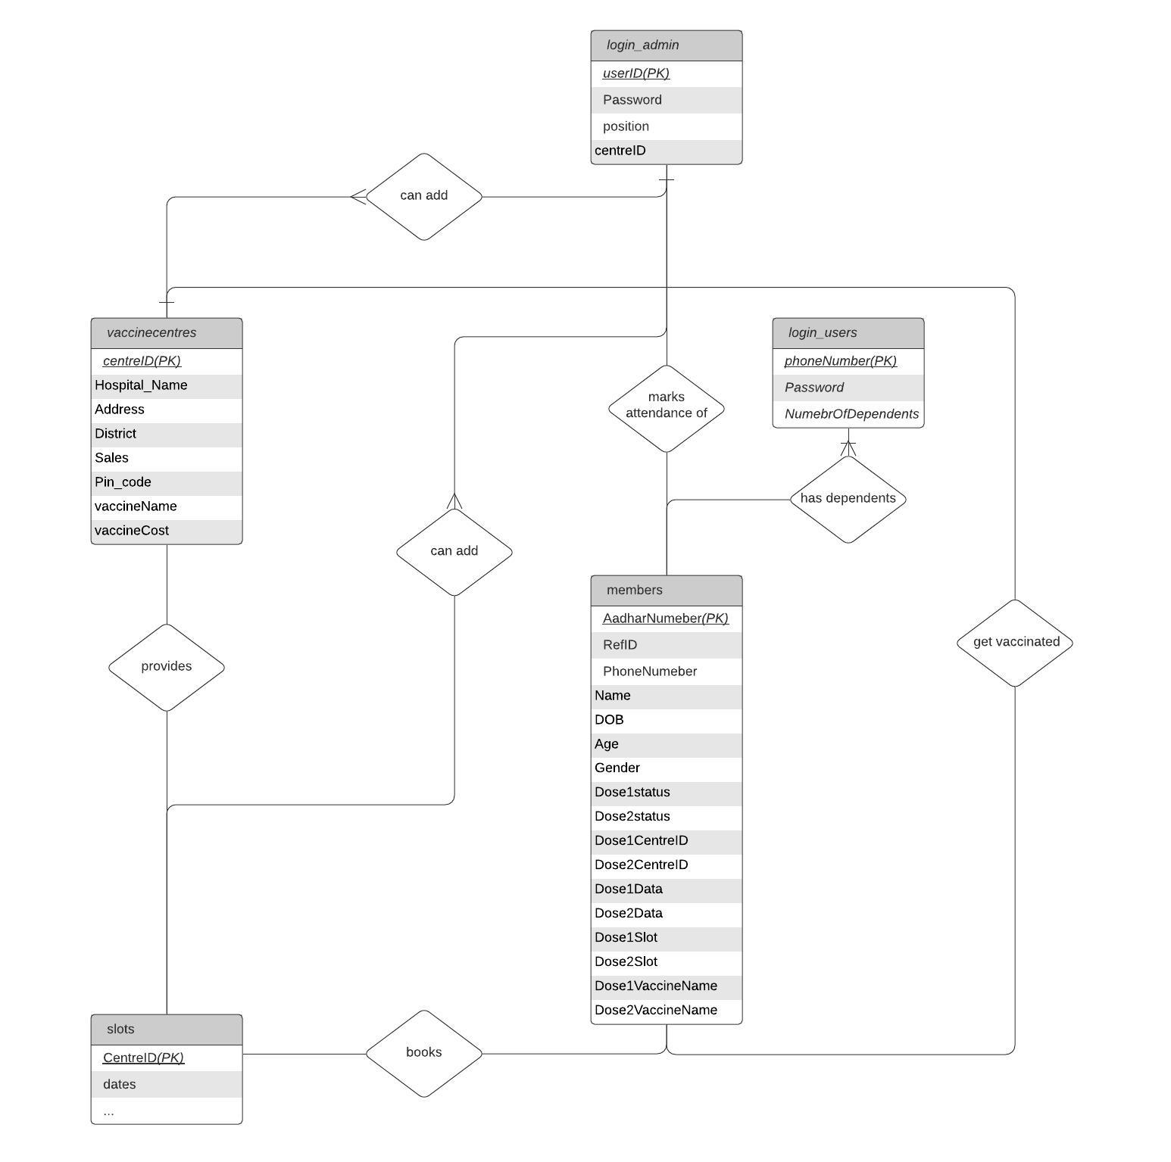

**DDL OPERATIONS**

Login Admin Table:

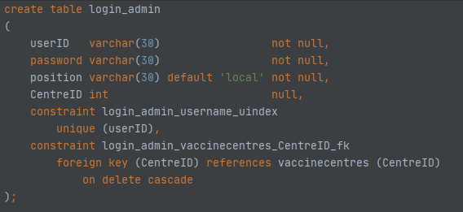

Fig 3.1

Login User Table:

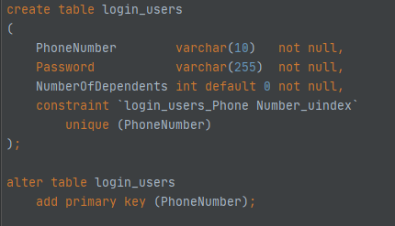

Fig 3.2

Members Table:

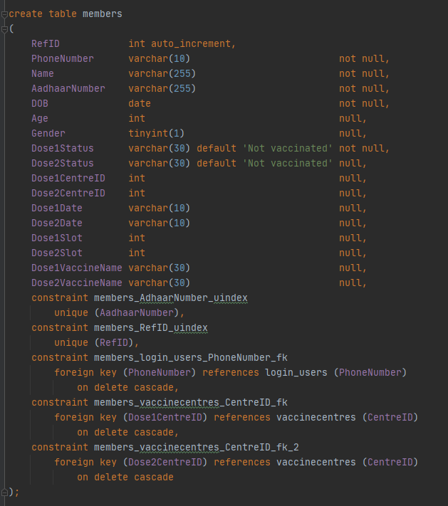

Fig 3.3

Vaccine Centres Table:

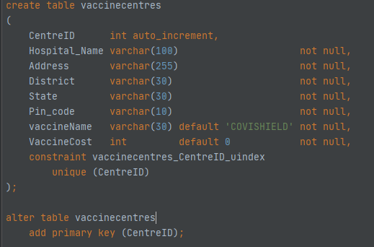

Fig 3.4

Slots Table:

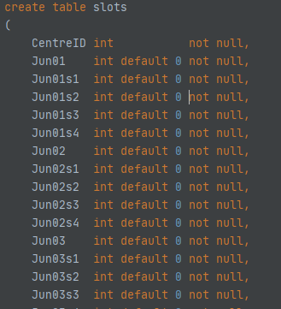

Fig 3.5